 | TEMASEK JUNIOR COLLEGE  2026 JC2 PRELIMINARY EXAMINATION  Higher 2 | 

GEOGRAPHY | 9173/01
Paper 1 | 31 August 2026  3 hours
Additional Materials: Insert

READ THESE INSTRUCTIONS FIRST

An answer booklet will be provided with this question paper. You should follow the instructions on the front cover of the answer booklet. If you need additional answer paper ask the invigilator for a continuation booklet.

Section A
Answer both questions.

Section B
Answer two questions, one from each cluster.

The number of marks is given in brackets [ ] at the end of each question or part question.

This document consists of 4 printed pages and 1 Insert.
Section A

Answer both questions.

Cluster 1: Development, Economy and Environment

1 | Resource 1 shows the flows of waste generated by global production networks (GPNs) in 2016. Resource 2 shows foreign direct investment (FDI) inflows by regions in 1990 and 2025. Resource 3 shows the production network for Apple, a technology transnational corporation headquartered in USA. Resource 4 shows the employment structure for selected countries.
 | (a) | Describe the pattern of waste flows shown in Resource 1. | [6]
 | (b) | Explain the shifts in global patterns of manufacturing and services since the 1950s. | [6]
 | (c) | Compare the FDI inflow across regions between 1990 and 2025 shown in Resource 2. | [5]
 | (d) | Explain how Apple’s production network shown in Resource 3 demonstrates interconnectedness within the global economy. | [6]
 | (e) | Using Resource 4, compare the employment structures between developed and developing economies. | [3]
 | (f) | Using examples, explain two ways in which the World Trade Organisation (WTO) has benefitted developing economies. | [4]

Cluster 2: Tropical Environments

2 | Resource 5 shows a mass movement in the tropics. Resource 6 shows the distribution of areas affected by tropical cyclones. Resource 7 shows the depth of groundwater in southern India in March and September. Resource 8 shows the water balance for a city in southern India.
 | (a) | Using Resource 5, describe the features of the mass movement shown. | [4]
 | (b) | Describe the distribution of areas affected by tropical cyclones shown in Resource 6. | [5]
 | (c) | Explain why tropical cyclones only affect specific areas around the world. | [5]
 | (d) | Using Resource 7, compare the depth of groundwater in southern India between March and September. | [5]
 | (e) | Using Resources 7 and 8, suggest reasons for the changes in the depth of groundwater in southern India between March and September. | [6]
 | (f) | Explain how the El Niño phase of the El Niño Southern Oscillation (ENSO) affects rainfall over the tropical Pacific. | [5]

Section B

Answer two questions from this section.

Answer either Question 3 or Question 4 and answer either Question 5 or Question 6.

Cluster 1: Development, Economy and Environment

3 | ‘Economic and political challenges present equally significant barriers to making progress towards sustainable development.’  Evaluate this statement. | [20]
4 | Evaluate whether states have the greatest influence on TNCs. | [20]
Cluster 2: Tropical Environments

5 | ‘Humans have limited control over the occurrence of fluvial floods.’  Evaluate this statement. | [20]
6 | Evaluate the extent to which weathering is the dominant geomorphic process in tropical areas. | [20]

TEMASEK JUNIOR COLLEGE

2026 JC2 PRELIMINARY EXAMINATION

Higher 2

GEOGRAPHY | 9173/01
Paper 1  INSERT | 31 August 2026
 | 3 hours

READ THESE INSTRUCTIONS FIRST

This Insert contains all the Resources referred to in the questions.

This document consists of 8 printed pages.

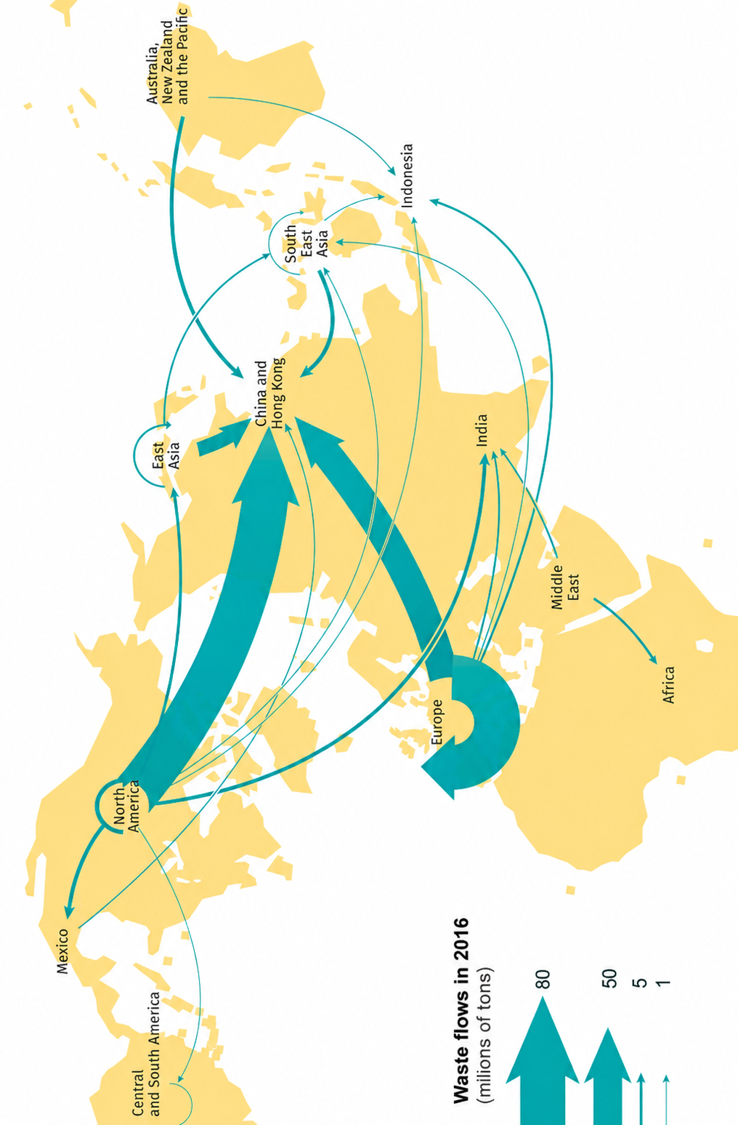

Resource 1 for Question 1

Flows of waste generated by global production networks (GPNs) in 2016

Resource 2 for Question 1

Foreign direct investment (FDI) inflows by regions in 1990 and 2025
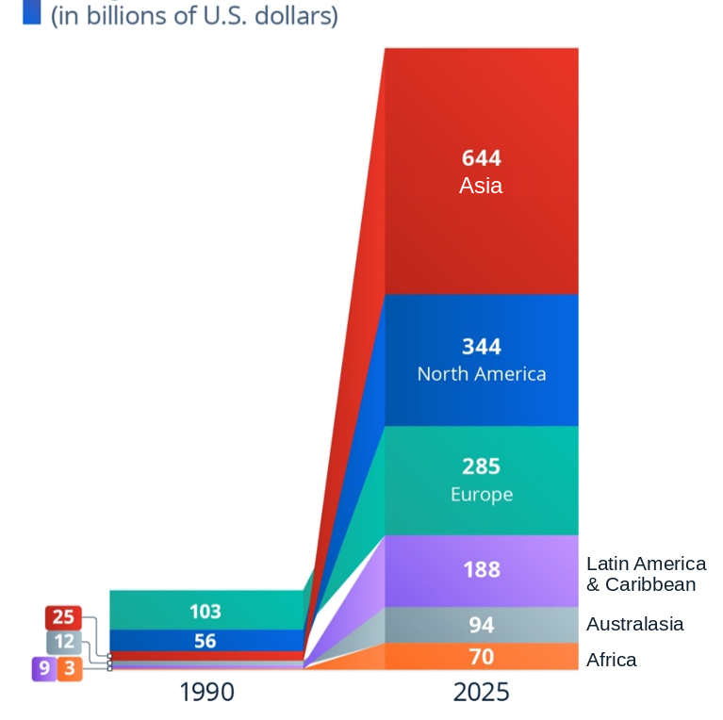

Resource 3 for Question 1

Apple’s production network
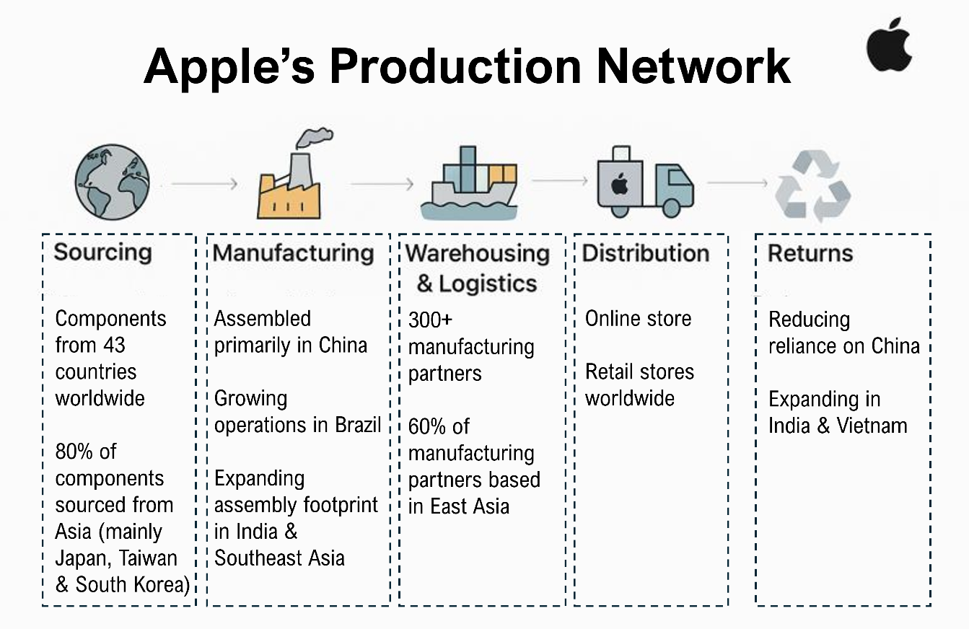

Resource 4 for Question 1

Employment structure for selected countries
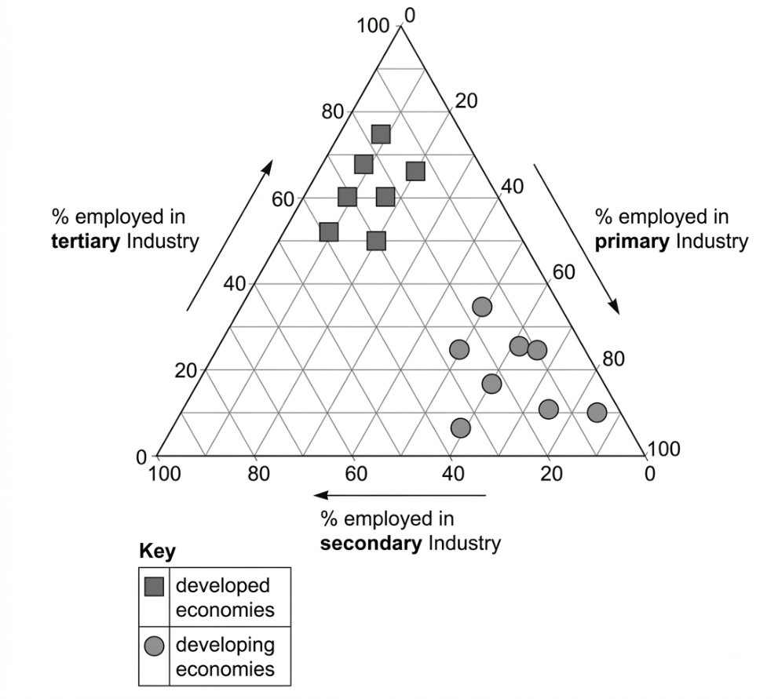
Resource 5 for Question 2

A mass movement in the tropics

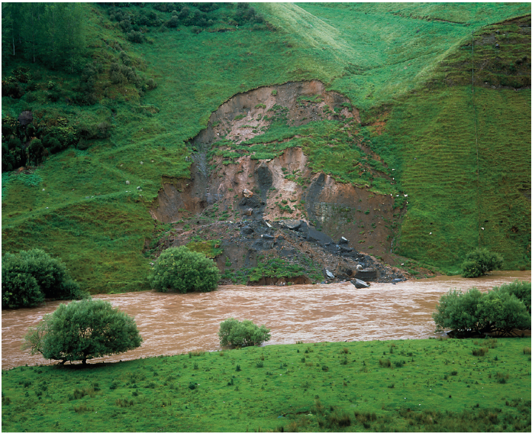

Resource 6 for Question 2

Distribution of areas affected by tropical cyclones

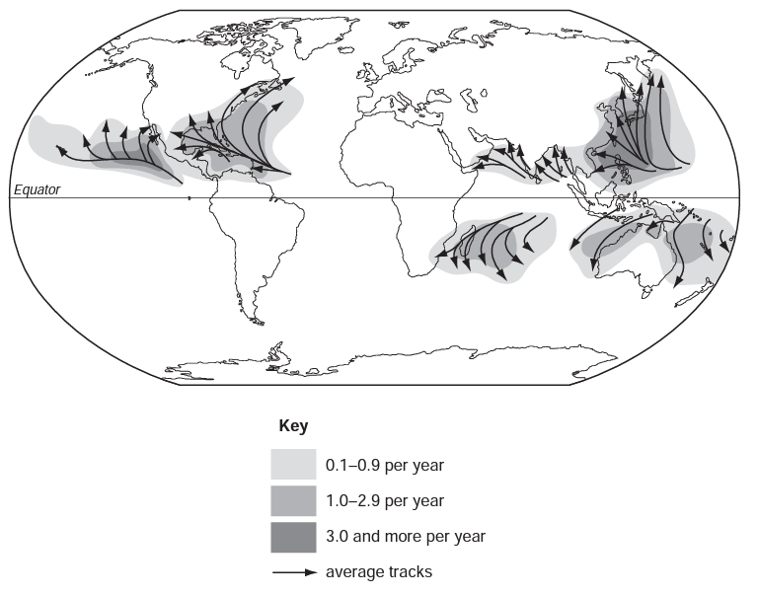
(Number of tropical cyclones per year)

Resource 7 for Question 2

Depth of groundwater in southern India in March and September

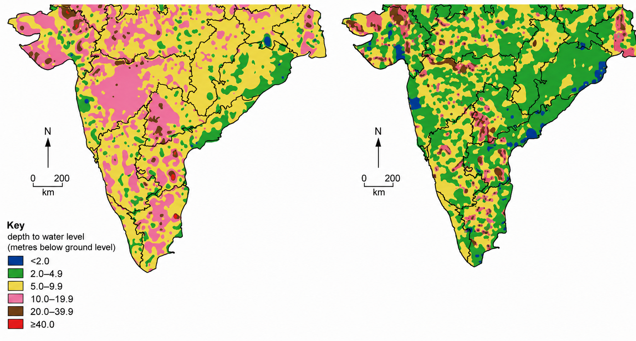

March September

Resource 8 for Question 2

Water balance for a city in southern India

